OBESITY LEVEL PREDICTION

A Course Project report submitted
in partial fulfillment of requirement for the award of degree

BACHELOR OF TECHNOLOGY
in
ARTIFICIAL INTELLIGENCE AND MACHINE LEARNING
by

K. PINKY ( 2203A54009)
M.SUHAS (2203A54014)
N. SHALINI (2203A54015)

Under the guidance of
RAMESH DADI
Assistant Professor, Department of CSE.


Department of Computer Science and Artificial Intelligence

OBESITY LEVEL PREDICTION
1.ABSTRACT
In modern times, obesity has become a significant threat all over the world. Obesity means an unnatural or excessive amount of fat that is present in our bodies. People are constantly moving towards an unhealthy lifestyle, eating excessive junk food, late-night sleep, spend a long time sitting down. Especially, adolescents are being affected because of their unconscious attitudes. It is a medical problem known as a very complex disease. It promotes the spread of complex illnesses, stroke, heart disease, liver cancer. The purpose of this project is for predicting the level of obesity using machine-learning algorithms. The people will know the level of obesity and the reasons behind their obesity, and helps them take decision for kind of treatment based on their level. We collect more than 2000 data from many varieties of people of different ages and collect information from both are suffering obesity and non-obesity. For this research, we apply three prominent machine learning algorithms. We used the algorithm of Logistic Regression, KNN, SVM, random forest, adaptive boosting (ADA boosting), decision tree, and we have measured the performance of each of these classifications in terms of some prominent performance metrics. From the experimental results, we determine the obesity of high, medium, and low. The SVM achieves the highest accuracy of 93.84% as compared to the other classifiers. In addition, the ADA boosting (adaptive boosting) algorithm gave the poorest accuracy of 32.80% as well as the lowest metric values.

2.INTRODUCTION
2.1. Overview
An excessive amount of body fat is called obesity. Obesity is not only about food genetic, and environmental can be the cause of obesity. Obesity occurs due to many reasons also. Thousands of risks and diseases are associated with obesity. It is one of the most common health problems all over the world. Excessively eating and moving too little is the reason for obesity. If people do not burn off their energy through physical activities, such as yoga, exercises, and so on, but take high amounts of energy, particularly fat and sugars, then much of the surplus energy is converted into fat and stored in the body. Most people are not concerned about their obesity as they thought it was one of the general health definitions. It is just the outer structure of their body. But the unfortunate reality is most of the diseases are associated with obesity. Sometimes it can cause death.
Obesity can grow in both adults and children. The imbalanced energy between calorie intake and expansion is likely to call the fundamental definition of obesity. If we see the obesity rate, then since 1975 worldwide obesity rate is nearly tripled. More than 650 million people were obese in 2016, and the overweight rate was 39% from the age of 18 years and older, where 13% were obese. In 2016 than 340,000 children were obese, and 34 million children under the age of 5years were obese in 2019. So, from the above information, it would not be wrong to say that obesity will become a leading threat to the whole world in the coming days. The aim of this project is to make people aware of the risk of obesity based on some key factors. The aspects of human life that can bring them obesity and the rate of obesity are presenting here. The analysis is conducted into two parts where firstly it read the data and then checks the data if it matches the factor with obesity, and then it will show the result. For our analysis, first, we collect raw data sets for our analysis depend on some factors. In addition, we pre-process those data, then we applied machine learning supervised algorithms to check the accuracy, precision, recall, and F₁-score.

2.2. Problem Statement
Predicting obesity levels using machine learning techniques in order to aware people at what level of obesity they are and how fast they need to take action. Obesity has become a significant threat all over the world. Obesity means an unnatural or excessive amount of fat that is present in our bodies. People are constantly moving towards an unhealthy lifestyle, eating excessive junk food, late-night sleep, spend a long time sitting down. Especially, adolescents are being affected because of their unconscious attitudes. It is a medical problem known as a very complex disease. It promotes the spread of complex illnesses, stroke, heart disease, liver cancer. The purpose of this project is for predicting the level of obesity using machine-learning algorithms.
2.3. Existing system
Most of the existed systems predicted obesity levels using the Body Mass Index, just by considering a person height and weight. Body Mass Index is a calculation that uses a person's weight, age, regular
activity, and height to measure body size. Body mass index (BMI) refers to the value of body weight divided by height class. It is extensively referred to as a substitute measure of fat mass due to its
availability. Obesity can also be measured by a BMI calculator. But this leads to wrong predictions due to different lifestyles of people.

2.4. Proposed system
The proposed expert system involves in understanding the different food habits and activities of people and predicting the obesity levels. Not only just the body mass index, heights, weights, here considering many factors such as lifestyle, eating excessive junk food, late-night sleep, spend a long time sitting down etc. and using machine learning techniques to predict the obesity levels accurately.
2.5. Define Objectives
The main objective of this is to predict the obesity levels based on lifestyles.
This helps the people to know at which level and to take necessary treatment.
Its goal is to lower disease rates through early detection of obesity. people will aware of factors that cause obesity through this.
2.6. Overall architecture
This system is regarded as a multiple-user access system, allowing numerous users to connect to the cloud simultaneously, as shown. There is only a single universal receiver shared by all users. An algorithm of machine learning system was created to classify obesity. Because it is a distributed system, the cloud is the best solution for a healthcare system that enables doctors to obtain data more easily. Our suggested system comprises four key phases: (1) data collecting, (2) data classification, (3) diagnosis, and (4) user
interface. Its goal is to lower disease rates through early detection of obesity.
The user’s task is inputted into the expert system as a string or numeric information, which is utilized to identify obesity in its early stages. After receiving a string input, the algorithm eliminates any extraneous
words that are found during the prediction stage. After eliminating superfluous words, the user-provided data are used by the prediction engine to make predictions.

- DATA PRE-PROCESSING
3.1. Describe dataset
This section was very difficult for us as it is the main stage for our research, so it was our main concern to collect the accurate data. We have collected our necessary data from various sources. The obesitydataset.csv file contains the data for this project. The number of instances (rows) in the data set is 2111, and the number of variables (columns) is 17. The number of input variables, or attributes for each sample, is 16. The input variables are numeric-valued, binary, and categorical. The number of target variable is 1 and represents the estimation of obesity levels in individuals.
Attributes:
The following list summarizes the variables information:
- gender: (1=Female or 0=Male).
- age: (Numeric).
- height: (Numeric).
- weight: (Numeric).
- family_history_with_overweight: (1=Yes/0=No).
- caloric_food:(0=Yes/1=No). Frequent consumption of high caloric food.
- vegatables: (1, 2 or 3). Frequency of consumption of vegetables.
- number_meals: (1, 2, 3 or 4). Number of main meals.
- food_between_meals: (1=No, 2=Sometimes, 3=Frequently or 4=Always). Consumption of food between meals.
- smoke: (0=Yes/1=No).
- water: (1, 2 or 3). Consumption of water daily.
- calories: (0=Yes/1=No). Calories consumption monitoring.
- activity: (0, 1, 2 or 3). Physical activity frequency.
- technology: (0, 1 or 2). Time using technology devices.
- alcohol: (1=No, 2=Sometimes, 3=Frequently or 4=Always). Consumption of alcohol.
- transportation: (Automobile, motorbike, bike, public transportation or walking). Transportation used.
- obesity_level: (1=Insufficient_Weight, 2=Normal_Weight, 3=Overweight_Level_I, 4=Overweight_Level_II, 5=Obesity_Type_I, 6=Obesity_Type_II, 7=Obesity_Type_III)
Here is the correlation matrix
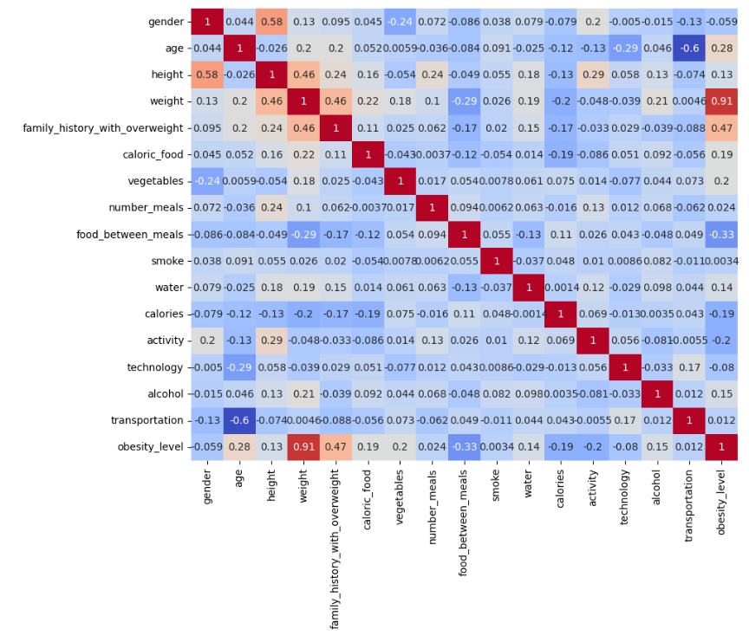

  - Data cleaning
This section was very difficult for us as it is the main stage for our research, so it was our main concern to collect the accurate data. We have collected our necessary data from various sources.
Data processing is the ability to transform data into a suitable format after collecting data. From the collected data, we got some missing data, categorical data, numerical and text data. Then we decided we would make this data suitable for algorithms through our data processing. As shown in below. we first started the work of data cleaning.
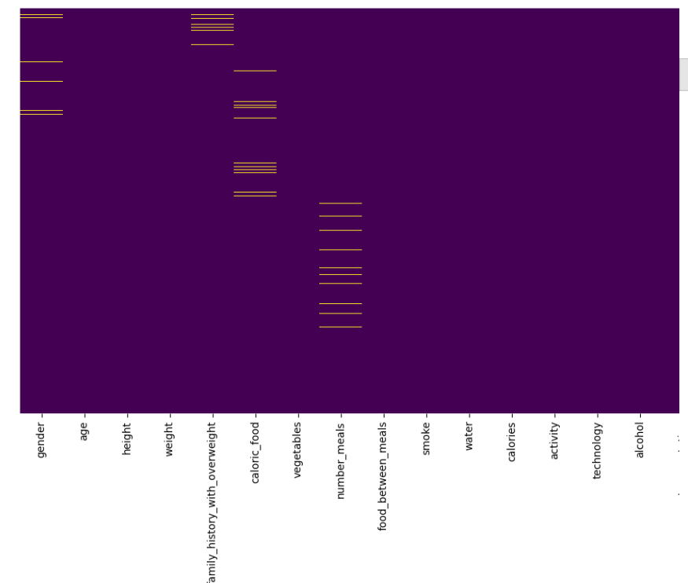

We checked if there is a null value in the data set, then we encoded the level that converts the text data to numerical data. We solved the missing value problem. Then we checked if there is a noisy value in the data set using a box plot. Here we can see that there was some noisy data in the numerical data. Then we analysed the correlation matrix as a data integration process. This matrix shows us the ratio of each data connected to each data. We removed noisy values by using outlier quantile detection. Then we dropped our outcome feature that was the obesity column. A separate histogram of each feature helped us with data reduction and data visualization in feature engineering. Through normalization, we completed the data transformation.
  - Data Visualization

In today’s world, a lot of data is being generated on a daily basis. And sometimes to analyze this data for certain trends, patterns may become difficult if the data is in its raw format. To overcome this data visualization comes into play. Data visualization provides a good, organized pictorial representation of the data which makes it easier to understand, observe, analyse. Once the data set has been set, we are ready to perform a few related analytics. We check the provided information and make sure that the data has good quality.
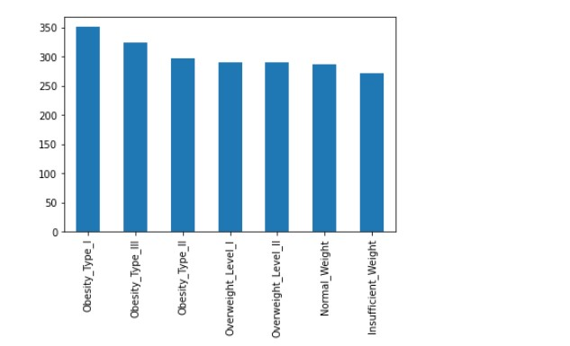
The graph shows the frequency of the people with different levels of obesity. From above bar graph we can clearly understand that in our dataset the most of the people are with obesity level- 1 and the data is perfect for training because the frequency of different levels is approximately same so it does not lead to any variance.
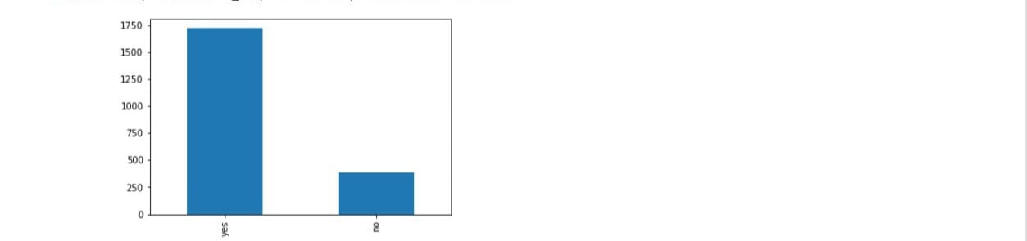
the above graph shows the frequency of the family history with overweight. This shows the family inheritance is also a factor for obesity.
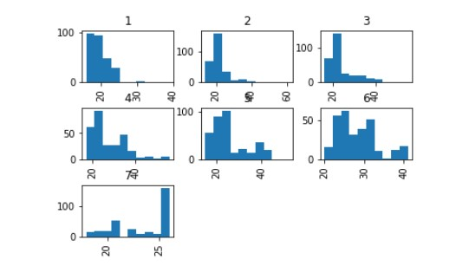
The above graph shows the number of people with obesity levels from 1 to 7 and their ages. By observing above graph, we noticed that obesity level 1 is among the people of age 16-25 and the level 6 of obesity is among the people of age 20-40. we can also see other levels of obesity of different age people as shown above.
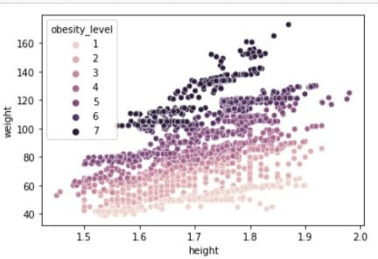
The above scatter plot is among heights and weights with respective to their obesity levels. We can clearly see that the more weight is the main factor of overweight. Here we can see some of data points are above 160 kgs which is overweight.
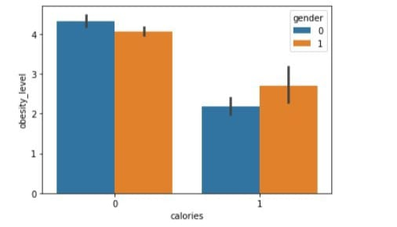
The above graph shows that bar plot between calories consumption and obesity levels. The calories consumption (0-yes /1-no) is also a factor of increase in weight. From the above graph it is clear that higher the calorie consumption there is risk in increasing of obesity levels.
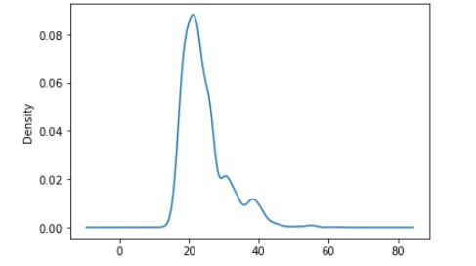
The above density graph of ages shows that the people of age between 16-30 age most suffering with this obesity, it might be because of their lifestyle. As they are adults, they may prefer eating junk foods which are high in calories and no interest in workouts makes them to get overweight.

The below are the Data Analysis graphs of the given data set of obesity level prediction.
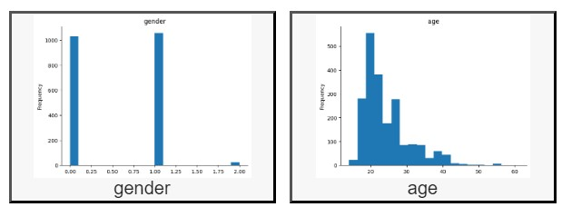
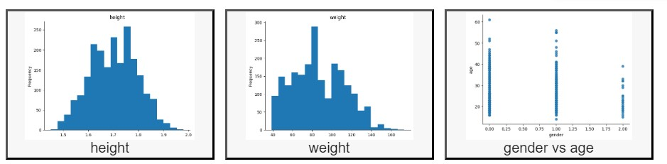
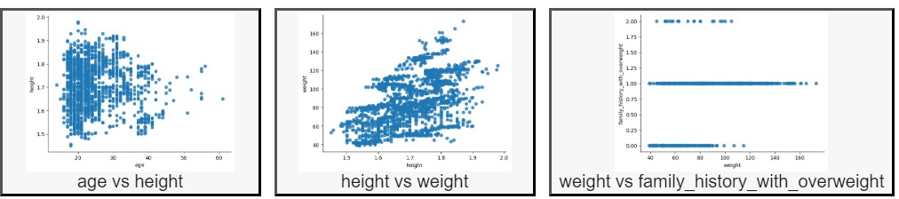
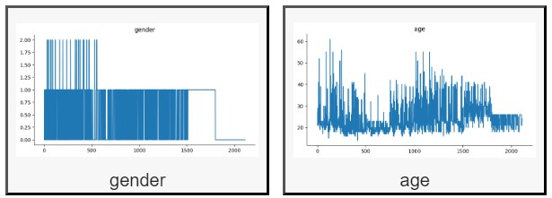
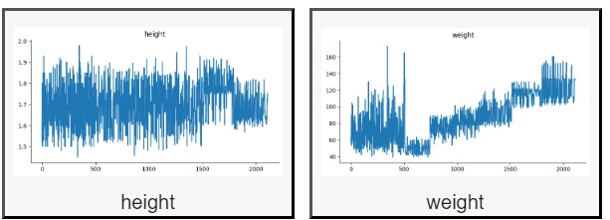

- METHODOLOGY
  - Procedure to solve the given problem
We have used a portion of the data for training data and the rest of the data were used for test data from our collected dataset. We collected 2111 rows of data. We have shown our data collection and data pre-processing techniques in the previous section. We have used several machine-learning supervised algorithms such as Logistic Regression, random forest, decision tree, adaptive boosting (Ada Boost), KNN, SVM. we calculated the accuracy. using the algorithm. We have evaluated metrics like sensitivity, specificity, precision, recall and F₁-score and the classifiers based on accuracy. The following flow diagram of these working processes has been described, which is given below in figure.

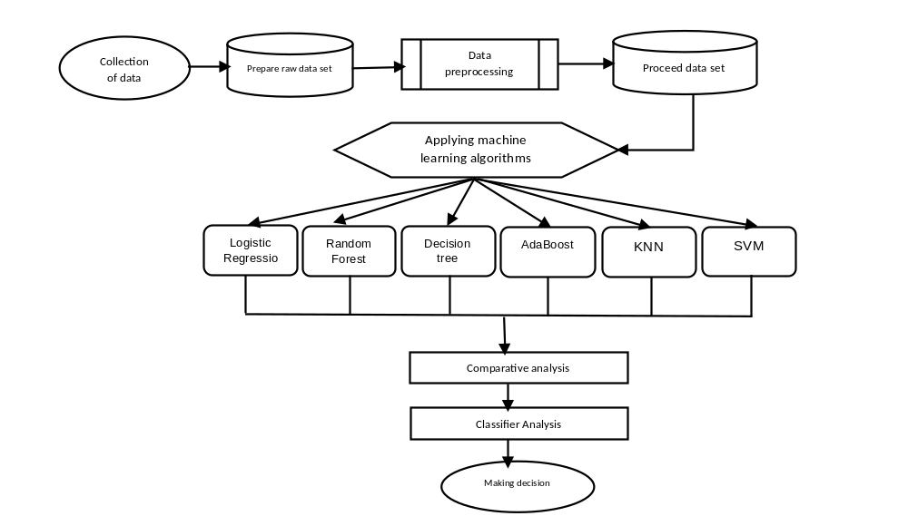

  - Model architecture

The system architecture of the prediction of obesity risk is as depicted in figure. This architecture is user-friendly, so anyone can use this system architecture. With this application, the user can view the user interface and can give the question and answer through the application. In this application, the user has to deliver some information about their daily activities, food routines, height, weight, etc. After fill-up, the form, the user sends a request to the server for the result, and then from there, the information collected form will go to the expert system. Periodically, the data is pre-processed and follows step the integration, missing value handling, box plot, data normalization, etc. Then prepare the data by splitting it into two sets. One part is the training set, and the other one is the set to test. The result will be resolved, dependent on the user input, by deploying a machine learning classifier of logistic regression algorithm to the processed information. Through the web application, the outcome will show in front of the user. The outcome showed the level of obesity.

We have inquired into the performance of the classifiers from the confusion matrix of dimension 7 × 7 since the number of class labels equals seven. We have calculated class-wise accuracy, precision, recall, and F₁-score. We calculated precision, recall, F₁-score of each algorithm along with accuracy. Accuracy is defined as the percentage of the total samples that were correctly recognized by the classifier. Precision is defined as the percentage of total predicted positive samples by the classifier that was actually positives. Recall means as the percentage of the total positive samples that were correctly predicted as positives by the classifier. F₁-score is the measurement of the harmonic mean of recall and precision. It considers both false positive and false negative values for calculation.
Precision can be defined as follows–
Accuracy= [No. of correctly classified samples/ No. of tested samples] × 100%
One must examine both precision and recall to fully evaluate the effectiveness of any model.
Precision can be defined as follows – Precision=[TP/(TP+FP)] × 100%
Recall can be defined as follows – Recall=[TP/(TP+FN)] × 100%
F₁-score is the measurement of the harmonic mean of recall and precision. It considers both false positive and false negative values for calculation– F1score=2× [(precision× recall)/ (precision+ recall)] ×100%
The three algorithms which have been used for our research, all of them have certain parameters. These parameters have different values which vary from each other.

3. RESULTS AND DISCUSSION
The performance is determined according to its accuracy, sensitivity, specificity, precision, recall, and F₁-score. The algorithm, which will fit best for our problem domain would be determined according to its performance. The highest performance given algorithm would be chosen as the most suitable algorithm. It is shown in the table that SVM has given the highest accuracy, specificity, precision, and F₁-score.

The comparitive analysis of Accuracy :
s.no | Model | accuracy
1 | Decision tree classifier | 60.88
2 | Ada boost classifier | 32.80
3 | Random forest classifier | 63.40
4 | SVM | 93.84
5 | Logistic Regression | 86.43
6 | KNN | 83.43

The below is the graph of accuracy of different models.
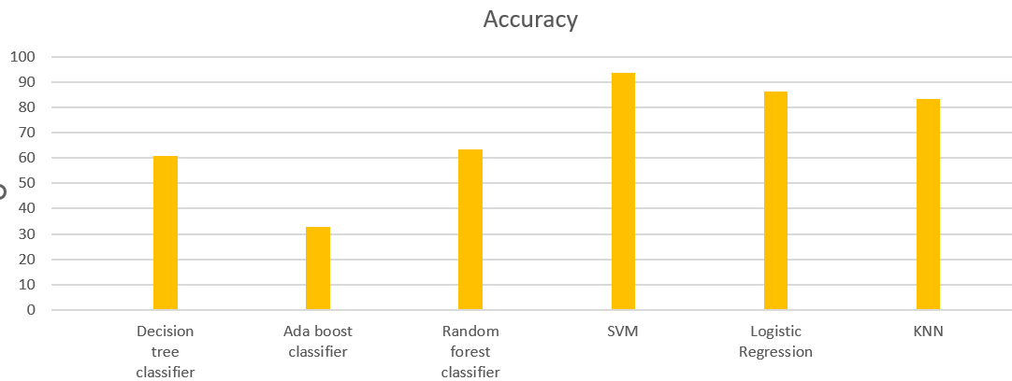

The comparitive analysis of Precision

Model  Level | Decision Tree | Random Forest Classifier | Ada Boost Classifier | SVM | Logistic Regression | KNN
1 | 0.83 | 0.59 | 0.00 | 0.91 | 0.90 | 0.80
2 | 0.53 | 0.62 | 0.38 | 0.92 | 0.87 | 0.77
3 | 0.45 | 0.57 | 0.45 | 0.87 | 0.75 | 0.70
4 | 0.00 | 0.62 | 0.00 | 0.94 | 0.79 | 0.80
5 | 0.43 | 0.60 | 0.27 | 0.97 | 0.89 | 0.88
6 | 0.88 | 0.62 | 0.00 | 0.95 | 0.87 | 0.96
7 | 1.00 | 0.75 | 0.00 | 1.00 | 0.98 | 0.96

4.CONCLUSION AND FUTURE SCOPE
We conclude that the dataset is not a complete space, and there are still other feature vectors missing from it. What we were attempting to generalize is a subspace of the actual input space, where the other dimensions are not known, and hence none of the classifiers were able to do better than SVM i.e. 93.84%. In the future, if similar studies are conducted to generate the dataset used in this report, more feature vectors need to be calculated so that the classifiers can form a better idea of the problem at hand.

5.REFERENCES
- The data for this problem has been taken from the UCI Machine Learning Repository.
- https://www.nhp.gov.in/disease/non-communicable-disease/obesity
- https://repositorio.cuc.edu.co/handle/11323/8417

